Week 5 ADVANCE HIVE PART 1

To optimize hive there are 3 ways,

- Design table to optimize queries (Partitioning and Bucketing of tables)
- Structure queries so they run faster (Join Optimizations)
- Simplify query expressions so they are easy to maintain (Window functions)

PARTITIONING:
- Partitioning is done on specific column if we use to search on that specific column then we get optimized and faster results otherwise there is no benefit.

- It is used mostly when we have large dataset because it only picks specific folder instead of whole folder.

- E.g, in managed table case data is store in such way like:
user/hive/warehouse/db_name.db/customer/
and then all files will be under customer folder (incase when there is no partitioning)

- In case of partitioning the folder will be like this:
/user/hive/warehouse/db_name.db/customers/state=CA
/user/hive/warehouse/db_name.db/customers/state=LA
/user/hive/warehouse/db_name.db/customers/state=ON
/user/hive/warehouse/db_name.db/customers/state=SF

so in this case hive will read and go for specifc state folder under cutomers folder instead of reading whole data so in this way our result will be much faster and optimized.

Select * from customers where state=CA and name=’abc’ (optimized and faster result)

select * from customers where name=’abc’ (not optimized result because partitioned column is not used)

NOTE:
if we make column partitioned which is distinct like customer_id (cardinality of customer_id is very high) and it will create a lot of folders which is not a good choice. And e.g, if we have 1 million distinct ids then in tat case “name node has to handle metadata for all this 1 million folders”. So in this case we should not go with partitioning rather we can go with bucketing. As otherwise it would overload the namenode of hadoop and only sometimes in some cases query might give good result but it would be degrading performance and overload.

Types of Partitioning:
- Static Partitioning
- Dynamic Partitioning

In static partitioning we already should know the data and we should be loading each partition manually. This is a tedious process.

In dynamic partitioning partitioning is loaded by automatically without done manually.

When we know data go with static partition otherwise go with dynamic partition.

Static partitioning is faster than dynamic partitioned. (Because in static we ask system to do in this way and in dynamic case system has to decide it by own that how to do it or create partitioning).

BUCKETING IN HIVE:

As we know partitioning works well when we have low cardinality(i.e, no. of distinct values in column is low. e.g, state) but if we are doing it with customer_id like the it is very bad choice. Because you will be ending up searching a lot of folders and will be adding over burdening.

In that case we have to go with bucketing a fix no. of bucketing while creating table.
We can’t say no. of buckets it depends on data.

In HDFS
- Partitioning is folder
- bucketing is files

e.g, we have distinct column ids and we created partitioning on it even though not a good idea but still then in that case, we e.g, define 3 buckets lets assume.

Then bucket names will be 0, 1, 2. (3 buckets)

id%no. Of buckets ----------------------> 1%3 = 1, (will go to bucket number 1)
2%2 = 2 (will go to bucket number 2)
3%3 = 0 (will go to bucket number 0)

so it will be reading specific files
when
select * from table where id=2 then it will straightly goes to file no. 2 / bucket no. 2.

Remember bucketing is not logical partition but partitioning is logical partitioning.

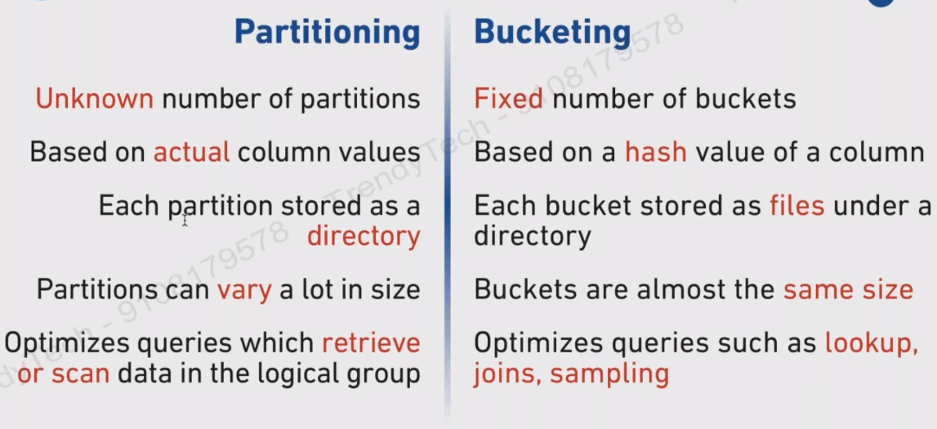
Bucketing Advantages:
- Faster query response
- Joins Optimization

------------------------------------------------------------------------------------------------------------------------

Table Creation with partitioning:

create table students(
id int,
name string,
address string
)
partitioned by (state str(2))
row format delimited fields terminated by ‘,’;

load data local inpath
‘/home/cloudera/downloads/orders.csv’
into table students
partition (state=”CA”);

set hive.exec.dynamic.partition = True;

----------------------------------------------------------------------------------------------------------------------

We should not use partitioning when cardinality of column is high.

Use bucketing in that case.

Bucketing works in same way but

partitioning provides logical division of data while bucketing provides data based on hash values.

Each bucketing is a file.

To create a bucket table we follow 3 steps:
- create normal hive table and load data in it
- create table with buckets defined
- load data from normal table to bucketed table

create table students(
id int,
name string,
address string
)
row format delimited fields terminated by ‘,’;

load data local inpath
‘/home/cloudera/downloads/orders.csv’
into table students ;

then

set hive.enforce.bucketing=true;

2) create table student_w_buckets(
id int,
name string,
address string
)
clustered by (id) into 4 BUCKETS;

3) from students insert into table student_w_buckets
select id, name, address;

Note: n buckets = n reducer means 4 buckets will make run 4 reducers

To display: select * from student_w_buckets tablesample(bucket 1 out of 4)

------------------------------------------------------------------------------------------------------------------------

Partitioning with 2 cols:

first set these properties:

set hive.exec.dynamic.partition = true;
set hive.exec.dynamic.partition.mode = nonstrict;

create table order_no_partition(
id int,
name varchar,
country varchar(2),
state varchar(2)
)
row format delimeted fields terminated by ‘,’;

load data local inpath ‘/home/cloudera/Downloads/orders.csv’ into table order_no_partition;

now

create table order_with_partition(
id int,
name varchar
)
partitioned by(country string, state string)
row format delimeted fields terminated by ‘,’;

insert into table order_with_partition partition(country, state) select * from order_no_partition;

------------------------------------------------------------------------------------------------------------------------------------------------------------------------------------------------------------------------------------------------

HIVE PARTITIONING WITH BUCKETING

Hive partitioning can further be subdivided into buckets
- Each partition will be created as directory
- Each bucket will be created as file

Forexample if we have partition on basis of state and bucketing on id(again id is unique therefore in partition) so in this case how it is optimized? It is optimized in that way

when we query

select * from table where state=’CA’ and id=4;

so since we have many folders depending on states like:
state=CA/
state=LA/
state=ON/

and e.g under each partition there are 4 files by bucketing so when we run above query it will go only partition where it is CA and only that specific one file which contained id 4 instead of reading all files under partitioned. So in this way it will be very much optimized. Tis is called structured level optimization.

Create partitioned table with bucketing

create table products_partitioned_buckets (
id int,
name string,
cost double
)
partitioned by (category string)
clustered by (id) into 4 buckets
row format delimited fields terminated by ‘,’;

now enabling:
set hive.exec.dynamic.partition = true;
set hive.exec.dynamic.partition.mode = nonstrict;
set hive.enforce.bucketing=true;

now loading data into table:

insert into table products_partitioned_buckets partition(category)
select id, name, cost, category
from products_no_buckets;

